Deploying 2048-Game on Nginx Server

* Snippet for the Dockerfile that will be used to build the image for the project is attached below.
* Ubuntu is used as the base Image
* Nginx Server is installed
* Code for the 2048 game is cloned from the GitHub repository
* Configurations of Nginx are updated to allow it to listen
* Port 80 of the Nginx server is exposed.

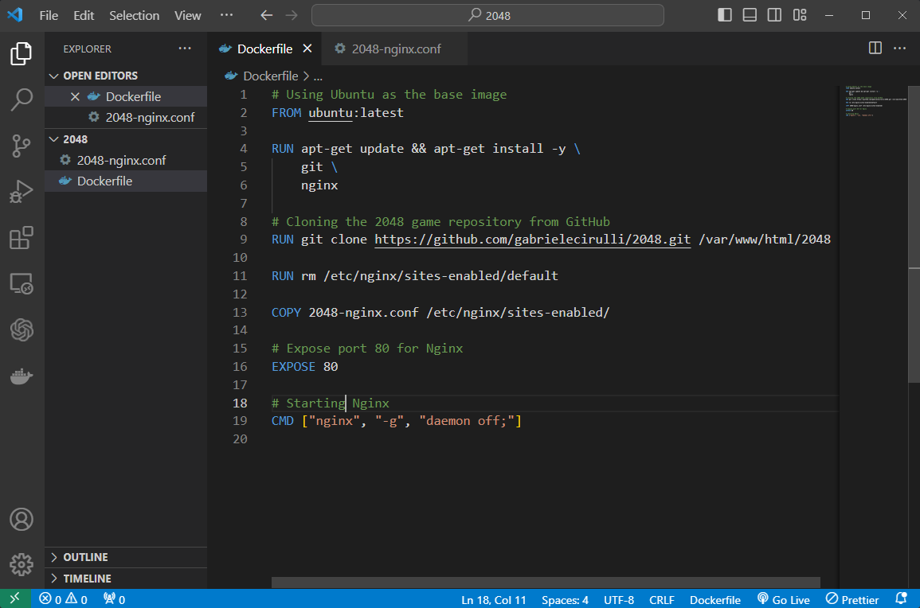

* Setting Up the configurations of Nginx server to listen on port 80:

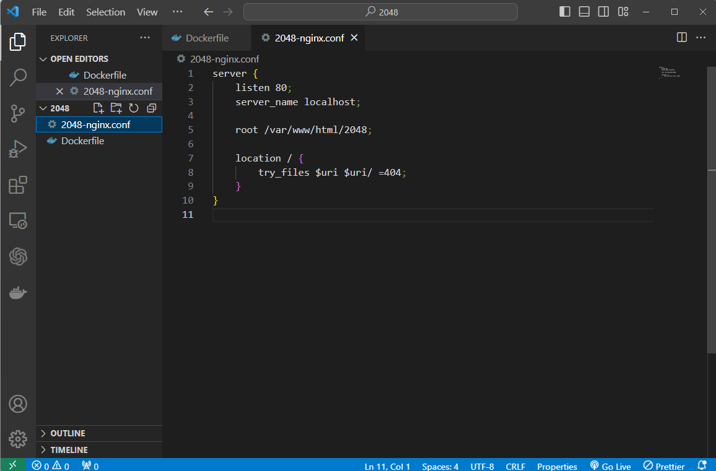

* Image is built using the docker command: ‘*docker build -t 2048-game .’* :

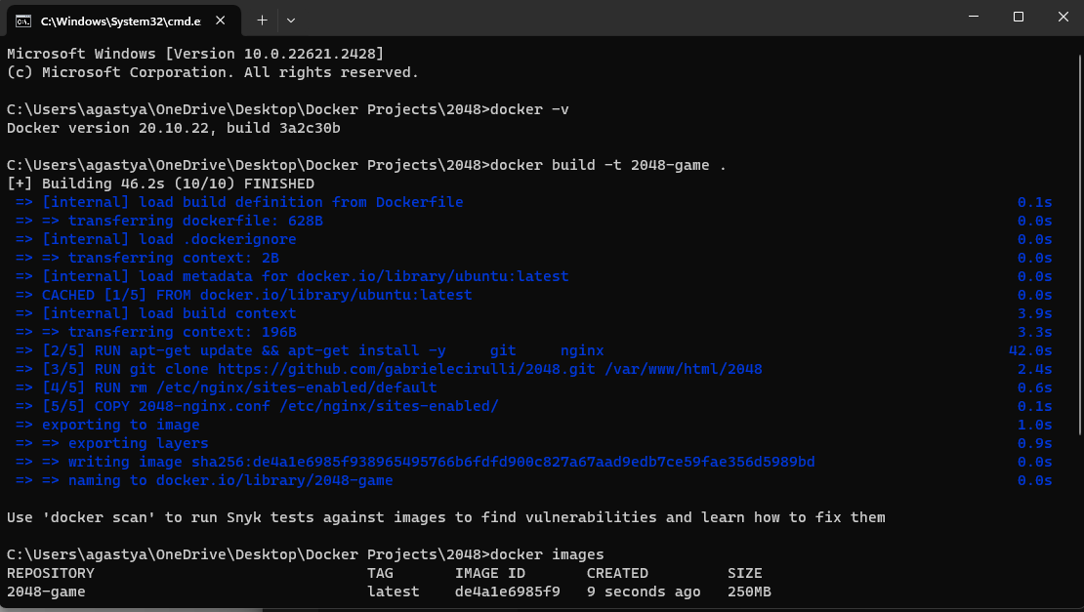

* Image is built and ready to be run in the container:

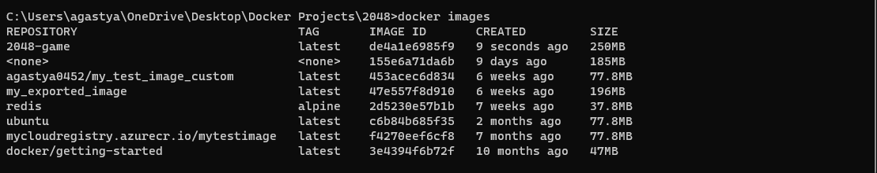

* Now checking port 8080 to see if the game is ready to play and accessible :

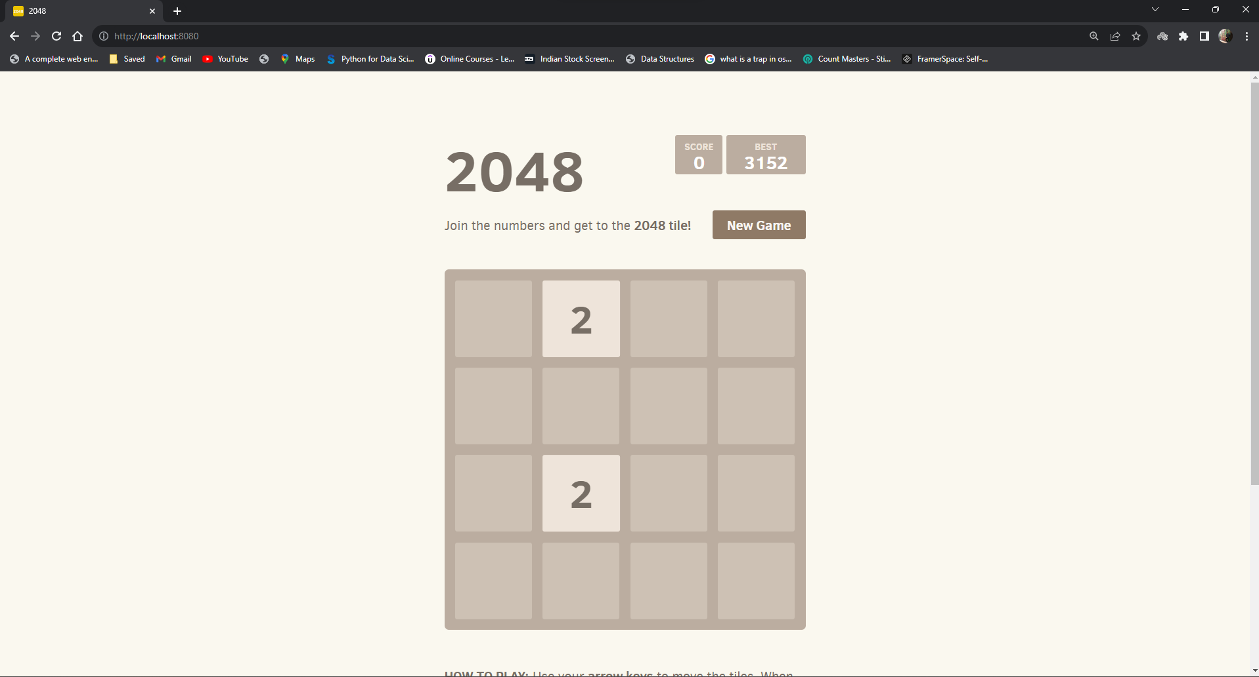

So, the game is up and running on ‘*localhost:8080*’ through Nginx server.